**Linear Combinations**

If $\vec{w}$ is the vector in vector space V, then $\vec{w}$ is said to be a linear combination of the vectors ${\vec{v}}_{1}, {\vec{v}}_{2}, … {\vec{v}}_{r}$ in V, if $\vec{w}$ can be expressed in the form $\vec{w}=k_{1}{\vec{v}}_{1}+k_{2}{\vec{v}}_{2}+…+k_{r}{\vec{v}}_{r},$ where $k_{1}, k_{2},…, k_{r}$ are scalars. These scalars are called the coefficients of linear combinations.

**Example 1:**

Let ${\vec{v}}_{1}=\left(1, 0, 0\right), {\vec{v}}_{2}=\left(0, 1, 0\right), {\vec{v}}_{3}=(0, 0, 1)$ in $R^{3}$. Then $\vec{w}=(2, 3, 4)$ can be written as linear combinations of ${\vec{v}}_{1},{\vec{v}}_{2}, {\vec{v}}_{3}$.

**Solution:**

$$\vec{w}=k_{1}{\vec{v}}_{1}+k_{2}{\vec{v}}_{2}+k_{3}{\vec{v}}_{3}$$

$$\left(2, 3, 4\right)=k_{1}\left(1, 0, 0\right)+k_{2}\left(0, 1, 0\right)+k_{3}\left(0, 0, 1\right)$$

$$\left(2, 3, 4\right)=2\left(1, 0, 0\right)+3\left(0, 1, 0\right)+4\left(0, 0, 1\right)$$

$$\vec{w}=2{\vec{v}}_{1}+3{\vec{v}}_{2}+4{\vec{v}}_{3}$$

**Example 2:**

Consider the vectors $\vec{v_{1}}=\left(1, 2, -1\right)$ and $\vec{v_{2}}=(6,4,2)$ in $R^{3}$. Show that $\vec{w}=(9, 2,7)$ is linear combination of $\vec{u}$ and $\vec{v}$.

Also prove that ${\vec{w}}^{'}=(4, -1, 8)$ is not linear combination of $\vec{v_{1}}$ and $\vec{v_{2}}$.

**Solution:**

In order to form linear combination of $\vec{v_{1}}$ and $\vec{v_{2}}$. there exist $k_{1}$ and $k_{2}$ such that

$$\vec{w}=k_{1}\vec{v_{1}} +k_{2}\vec{v_{2}}.$$

$$\left(9,2,7\right)=k_{1}\left(1, 2, -1\right)+k_{2}\left(6,4,2\right)$$

$$\left(9,2,7\right)=\left(k_{1}, 2k_{1}, -k_{1}\right)+\left(6k_{2},4k_{2},2k_{2}\right)$$

$$\left(9,2,7\right)=\left(k_{1}+6k_{2}, 2k_{1}+4k_{2}, -k_{1}+2k_{2}\right)$$

Equating corresponding components gives:

$$k_{1}+6k_{2}=9$$

$$2k_{1}+4k_{2}=2$$

$$-k_{1}+2k_{2}=7$$

Solving this system by using Gauss Elimination:

$$\left[\begin{matrix}1 \\ 2 \\ -1 \end{matrix}\begin{matrix}6 | \\ 4 | \\ 2 |\end{matrix}\begin{matrix}9 \\ 2 \\ 7\end{matrix}\right]$$

$$\left[\begin{matrix}1 \\ 0 \\ 0 \end{matrix}\begin{matrix} 6 | \\ -8 | \\ 8 |\end{matrix}\begin{matrix}9 \\ -16 \\ 16\end{matrix}\right] R_{2}-2R_{1} and R_{3}+R_{1}$$

$$\left[\begin{matrix}1 \\ 0 \\ 0 \end{matrix}\begin{matrix} 6 \\ 1 \\ 1\end{matrix}\begin{matrix}9 \\ 2 \\ 2\end{matrix}\right] -\frac{R_{2}}{8} and \frac{R_{3}}{8}$$

$$\left[\begin{matrix}1 \\ 0 \\ 0 \end{matrix}\begin{matrix} 6 \\ 1 \\ 0\end{matrix}\begin{matrix}9 \\ 2 \\ 0\end{matrix}\right] R_{3}-R_{2}$$

$$\left\{\begin{aligned}k_{1}+6k_{2}=9 ----(1) \\ k_{2}=2 \\ 0=0\end{aligned}\right.$$

Put value of $k_{2}=2$ in (1), we get:

$$k_{1}+6\left(2\right)=9$$

$$k_{1}=9-12$$

$$k_{1}=-3$$

So

$$\vec{w}=-3\vec{u}+2\vec{v}$$

That is $$\left(9,2,7\right)=-3\left(1, 2, -1\right)+2\left(6,4,2\right)$$

So $\vec{w}$ is the linear combination of $\vec{v_{1}}$ and $\vec{v_{2}}$.

Similarly, we have to check whether $\vec{w}'$ is linear combination of $\vec{v_{1}}$ and $\vec{v_{2}}$.

If $\vec{w}'$ is linear combination of $\vec{v_{1}}$ and $\vec{v_{2}}$. then there must exist $k_{1}$ and $k_{2}$, such that:

$$\vec{w'}=k_{1}\vec{v_{1}} +k_{2}\vec{v_{2}}$$

$$\left(4, -1, 8\right)=k_{1}\left(2, 2, -1\right)+k_{2}\left(6,4,2\right)$$

$$\left(4, -1, 8\right)=\left(2k_{1}+6k_{2}, 2k_{1}+4k_{2}, -k_{1}+2k_{2}\right)$$

$$\left\{\begin{aligned}4=k_{1}+6k_{2} \\ -1=2k_{1}+4k_{2} \\ 8=-k_{1}+2k_{2}\end{aligned}\right.$$

$$\left[\begin{matrix}1 & 6 & 4 \\ 2 & 4 & -1 \\ -1 & 2 & 8\end{matrix}\right]$$

$$\left[\begin{matrix}1 & 6 & 4 \\ 0 & -8 & -9 \\ 0 & 8 & 12\end{matrix}\right] R_{2}-2R_{1} and R_{3}+R_{1}$$

$$\left[\begin{matrix}1 & 6 & 4 \\ 0 & 1 & \frac{9}{8} \\ 0 & 2 & 3\end{matrix}\right] -\frac{1}{8}R_{2} and {\frac{1}{4}R}_{3}$$

$$\left[\begin{matrix}1 & 6 & 4 \\ 0 & 1 & \frac{9}{8} \\ 0 & 0 & \frac{3}{2}\end{matrix}\right] R_{3}-2R_{2}$$

$$\left\{\begin{aligned}k_{1}+6k_{2}=4 \\ k_{2}=\frac{9}{8} \\ 0=\frac{3}{2}\end{aligned}\right.$$

This system has no solution. So, no such $k_{1}$ and $k_{2}$ exist. So $\vec{w}'$ is not the linear combination of $\vec{v_{1}}$ and $\vec{v_{2}}$.

**Example 3:**

Which of the following are linear combination of $\vec{u}=\left(0, -2, 2\right)$ and $\vec{v}=\left(1,3,-1\right).$

1. (2, 2, 2)
2. (3,1,5)
3. (0,4,5)
4. (0,0,0)

**Example 4:**

Express the following as linear combination of $\vec{u}=\left(2,1,4\right),\vec{v}=\left(1,-1,3\right),\vec{w}=(3,2,5)$

1. (-9, -7,-15)
2. (66,11,6)
3. (0,0,0)
4. (7,8,9)

**Example 5:**

Which of the following is the linear combination of

$$A=\left[\begin{matrix}4 & 0 \\ -2 & -2\end{matrix}\right] B=\left[\begin{matrix}1 & -1 \\ 2 & 3\end{matrix}\right] C=\left[\begin{matrix}0 & 2 \\ 1 & 4\end{matrix}\right]$$

$M=\left[\begin{matrix}6 & -8 \\ -1 & -8\end{matrix}\right]$

$N=\left[\begin{matrix}6 & 0 \\ 3 & 8\end{matrix}\right]$

$O=\left[\begin{matrix}0 & 0 \\ 0 & 0\end{matrix}\right]$

$P=\left[\begin{matrix}-1 & 5 \\ 7 & 1\end{matrix}\right]$

**Solution:**

$$M=k_{1}A+k_{2}B+K_{3}C$$

$$\left[\begin{matrix}6 & -8 \\ -1 & -8\end{matrix}\right]=k_{1}\left[\begin{matrix}4 & 0 \\ -2 & -2\end{matrix}\right] +k_{2}\left[\begin{matrix}1 & -1 \\ 2 & 3\end{matrix}\right]+k_{3}\left[\begin{matrix}0 & 2 \\ 1 & 4\end{matrix}\right]$$

$$\left[\begin{matrix}6 & -8 \\ -1 & -8\end{matrix}\right]=\left[\begin{matrix}4k_{1} & 0 \\ -2k_{1} & -2k_{1}\end{matrix}\right] +\left[\begin{matrix}k_{2} & -k_{2} \\ 2k_{2} & 3k_{2}\end{matrix}\right]+\left[\begin{matrix}0 & 2k_{3} \\ k_{2} & 4k_{3}\end{matrix}\right]$$

$$\left[\begin{matrix}6 & -8 \\ -1 & -8\end{matrix}\right]=\left[\begin{matrix}4k_{2}+k_{2} & -k_{2}+2k_{3} \\ -2k_{1}+2k_{2}+k_{3} & -2k_{1}+3k_{2}+4k_{3}\end{matrix}\right]$$

$$6=4k_{1}+k_{2}-----(1)$$

$$-8=-k_{2}+2k_{3}-----(2)$$

$$-1=-2k_{1}+2k_{2}+k_{3}-----(3)$$

$$-8=-2k_{1}+3k_{2}+4k_{3}-----\left(4\right)$$

Add (1) and (2):

$$6=4k_{1}+k_{2}$$

$$-8=-k_{2}+2k_{3}$$

$$-1=2k_{1}+k_{3}$$

$k_{3}=-1-2k_{1}$, put in (3)

$$-1=-2k_{1}+2k_{2}+k_{3}$$

$$-1=-2k_{1}+2k_{2}+\left(-1-2k_{1}\right)$$

$$-1=-2k_{1}+2k_{2}-1-2k_{1}$$

$$-1+1=-4k_{1}+2k_{2}$$

$$-4k_{1}+2k_{2}=0------\left(5\right)$$

Add (1) and (5)

$$4k_{1}+k_{2}=6$$

$$-4k_{1}+2k_{2}=0$$

$$3k_{2}=6$$

$k_{2}=2,$ Put in (1)

$$4k_{1}+2=6$$

$$4k_{1}=4$$

$$k_{1}=1$$

$k=2,$ put in (2)

$$-8=-2+2k_{3}$$

$$-8+2=2k_{3}$$

$$k_{3}=-3$$

Put $k_{1}=1, k_{2}=2, k_{3}=-3$ in (4)

$$-8=-2\left(1\right)+3\left(2\right)+4\left(-3\right)$$

$$-8=-2+6-12$$

$$-8=-8$$

$$M=1A+2B-3C$$

$$\left[\begin{matrix}6 & -8 \\ -1 & -8\end{matrix}\right]=\left[\begin{matrix}4 & 0 \\ -2 & -2\end{matrix}\right] +2\left[\begin{matrix}1 & -1 \\ 2 & 3\end{matrix}\right]-3\left[\begin{matrix}0 & 2 \\ 1 & 4\end{matrix}\right]$$

So $\left[\begin{matrix}6 & -8 \\ -1 & -8\end{matrix}\right]$ is linear combination of A, B and C.

**Polynomials of degree n:**

$$P\left(t\right)=a_{n}t^{n}+a_{n-1}t^{n-1}+…+a_{1}t+a_{0}; a_{n}, a_{n-1}, a_{n}, …, a_{1}, a_{0}∈R and a_{n}≠0$$

Let $P_{n}$ is the set of all polynomials of degree n, form vector space under addition and scalar multiplication defined by:

$$p\left(t\right)=a_{n}t^{n}+a_{n-1}t^{n-1}+…+a_{1}t+a_{0}$$

$$q\left(t\right)=b_{n}t^{n}+b_{n-1}t^{n-1}+…+b_{1}t+b_{0}$$

$$p\left(t\right)+q\left(t\right)={(a}_{n}+b_{n})t^{n}+{(a}_{n-1}+b_{n-1})t^{n-1}+…+\left(a_{1}+b_{1}\right)t+{(a}_{0}+b_{0})$$

If k is any scalar then

$$kp\left(t\right)=k(a_{n})t^{n}+k(a_{n-1})t^{n-1}+…+k(a_{1})t+{k(a}_{0})$$

Then $P_{n}$ is vector space.

**Example 6:**

In each part the vectors are as linear combination of $P_{1}=2+x+4x^{2}$, $P_{2}=1-x+3x^{2}$ and $P_{3}=3+2x+5x^{2}$

$-9-7x-15x^{2}$

$6+11x+6x^{2}$

$0$

$7+8x+9x^{2}$

**Solution:**

$$-9-7x-15x^{2}=k_{1}P_{1}+k_{2}P_{2}+k_{3}P_{3}$$

$$-9-7x-15x^{2}=k_{1}\left(2+x+4x^{2}\right)+k_{2}\left(1-x+3x^{2}\right)+k_{3}\left(3+2x-5x^{2}\right)$$

$$-9-7x-15x^{2}=2k_{1}+k_{1}x+4k_{1}x^{2}+k_{2}-k_{2}x+3k_{2}x^{2}+3k_{3}+2k_{3}x-5k_{3}x^{2}$$

$$=\left(2k_{1}+k_{2}+3k_{3}\right)+\left(k_{1}x-k_{2}x+2k_{3}x\right)+\left(4k_{1}x^{2}+3k_{2} x^{2}-5k_{3}x^{2}\right)$$

$$-9-7x-15x^{2}=\left(2k_{1}+k_{2}+3k_{3}\right)+\left(k_{1}-k_{2}+2k_{3}\right)x+\left(4k_{1}+3k_{2} -5k_{3}\right)x^{2}$$

Comparing equations on both sides, we get:

$$\left\{\begin{aligned}-9=2k_{1}+k_{2}+3k_{3}----(1) \\ -7=k_{1}-k_{2}+2k_{3}-----(2) \\ -15=4k_{1}+3k_{2}-5k_{3}----(3)\end{aligned}\right.$$

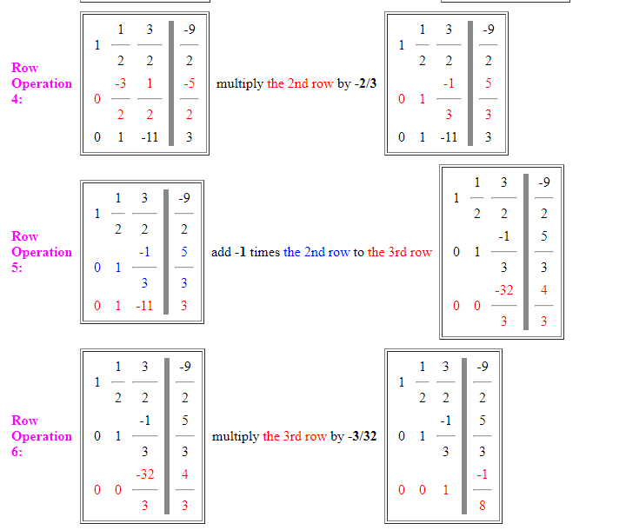

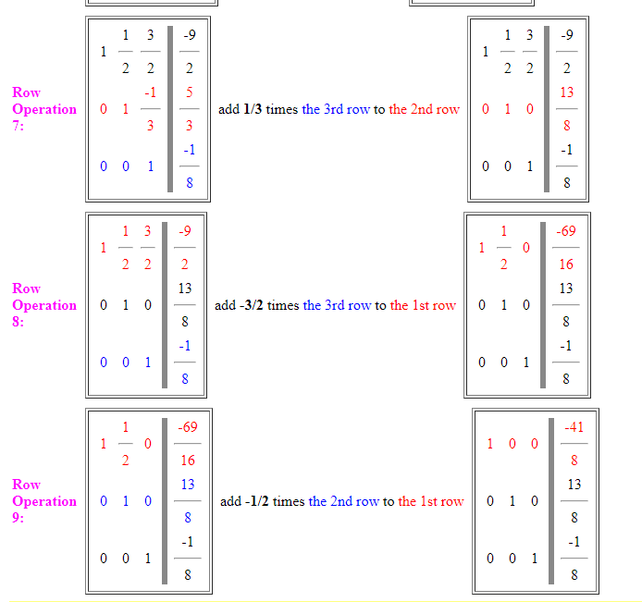

As $k_{1}=-\frac{41}{8}, k_{2}=\frac{13}{8}, k_{3}=-\frac{1}{8}$

$$-9-7x-15x^{2}=-\frac{41}{8}\left(2+x+4x^{2}\right)+\frac{13}{8}\left(1-x+3x^{2}\right)-\frac{1}{8}\left(3+2x-5x^{2}\right)$$

So $-9-7x-15x^{2}$ is linear combination of $P_{1}, P_{2}, P_{3}.$